**Power BI Assignment 2**

**1. Explain the advantages of Natural Queries in Power Bi with an example?**

Q&A displays a new screen with suggestions to help you form your question. Start either from one of the suggested questions or type your own questions. Q&A supports a wide range of questions, including but not limited to:

* **Ask natural questions-** Which sales has the highest revenue?
* **Use relative date filtering** - Show me sales in the last year
* **Return only the top N-** Top 10 products by sales
* **Provide a filter-** Show me sales in the USA
* **Provide complex conditions-** Show me sales where product category is Category 1 or Category 2
* **Return a specific visual-** Show me sales by product as pie chart
* **Use complex aggregations-** Show me median sales by product
* **Sort results-** Show me top 10 countries/regions by sales ordered by country or region code
* **Compare data-** Show me date by total sales vs total cost
* **View trends**- Show me sales over time

**Autocomplete-**

As you type your question, Power BI Q&A shows relevant and contextual suggestions to help you quickly become productive with natural language. As you type, you get immediate feedback and results. The experience is similar to typing in a search engine.

**Red/Blue/Orange Underlines-**

Q&A shows words with underlines to help you see which words the system understood or didn't recognize. A solid blue underline indicates that the system successfully matched the word to a field or value in the data-model. The example below shows that Q&A recognized the word EU Sales.

**Visualization Results-**

As you type your question, Q&A tries to instantly interpret and visualize the answer. As part of the latest updates, Q&A now tries to interpret the question and plot the fields automatically to the correct axis. For example, if you type 'Sales by year', Q&A detects that year is a date field and always prioritizes placing this field on the X axis. If you want to change the visualization type, type 'as chart type' after the question. Q&A currently supports these types of visualizations:

* Line chart
* Bar chart
* Matrix
* Table
* Card
* Area
* Pie chart
* Scatter/Bubble chart
* Map
  1. **Explain Web Front End (WFE) cluster from Power BI Service Architecture?**

The **WFE** cluster manages the initial connection and authentication to the Power BI service.

It uses Azure AD to authenticate clients, and provide tokens for subsequent client connections to the Power BI service. Power BI uses the **Azure Traffic Manager** (Traffic Manager) to direct user traffic to the nearest data center. Traffic Manager directs requests using the DNS record of the client attempting to connect, authenticate, and to download static content and files. Power BI uses the **Azure Content Delivery Network** (CDN) to efficiently distribute the necessary static content and files to users based on geographical locale.

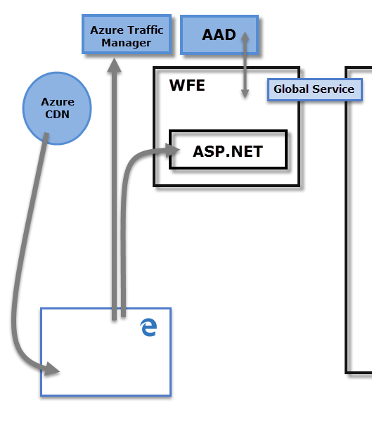

* 1. **Explain Back End cluster from Power BI Service Architecture?**

The **Back-End** handles all subsequent user interactions. Power BI uses Azure Active Directory (Azure AD) to store and manage user identities. Azure AD also manages data storage and metadata using Azure BLOB and Azure SQL Database, respectively.

It determines how authenticated clients interact with the Power BI service. The **Back-End** cluster manages visualizations, user dashboards, datasets, reports, data storage, data connections, data refresh, and other aspects of interacting with the Power BI service. The **Gateway Role** acts as a gateway between user requests and the Power BI service. Users don't interact directly with any roles other than the **Gateway Role**. **Azure API Management** eventually handles the **Gateway Role**.

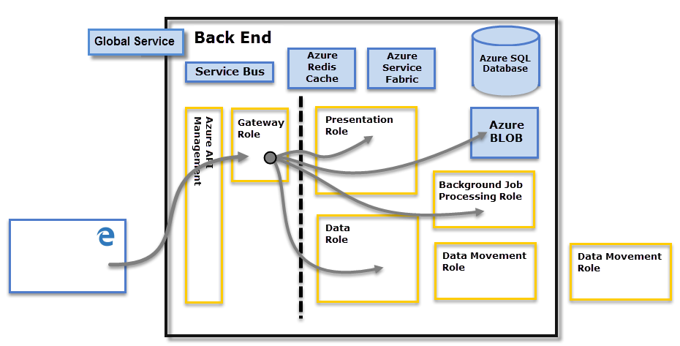

* 1. **What ASP.NET component does in Power BI Service Architecture?**

A WFE cluster consists of an ASP.NET website running in the [Azure App Service Environment](https://learn.microsoft.com/en-us/azure/app-service/environment/intro). When users attempt to connect to the Power BI service, the client's DNS service may communicate with the Azure Traffic Manager to find the most appropriate (usually nearest) datacenter with a Power BI deployment.

* 1. **Compare Microsoft Excel and Power BI Desktop.**

|  |  |  |
| --- | --- | --- |
| **Features** | **Microsoft Excel** | **Power BI Desktop** |
| **Data import** | Data can be import either in .txt or csv format | Data can be import in any format. Ex- Excel, Snowflake, XML etc |
| **Data transformation** | Data transform through power query | Data transform through power query |
| **Modelling** | Excel is totally focused on structured and simple[data models](https://www.educba.com/data-models-in-dbms/) with a wide range of features. | Power BI is really focused on data ingest and building potentially complex data models easily. |
| **Reporting** | Excel reports are normal and ordinary | Power BI offers Beautiful branded reports |
| **Cost** | Since we already have Excel, we need to spend additional money to procure this and build dashboards. | Power BI Desktop is free to download and use for personal use, but it takes $10 per month per user to share reports with others. |

* 1. **List 20 data sources supported by Power Bi desktop.**

1. Excel Workbook
2. Text/CSV
3. XML
4. JSON
5. Folder
6. PDF
7. Parquet
8. SharePoint folder
9. SQL Server database
10. Access database
11. SQL Server Analysis Services database
12. Oracle database
13. IBM Db2 database
14. MySQL database
15. PostgreSQL database
16. SAP HANA database
17. Amazon Redshift
18. Google BigQuery
19. Vertica
20. Snowflake